How to book a room through the booking portal?
- Please visit the site URL : http://cbs.iitrpr.ac.in/Web/?
- Put your LDAP username and password. Your LDAP credentials will same in all the portal like medh servers (Moodle) and booking portal etc.
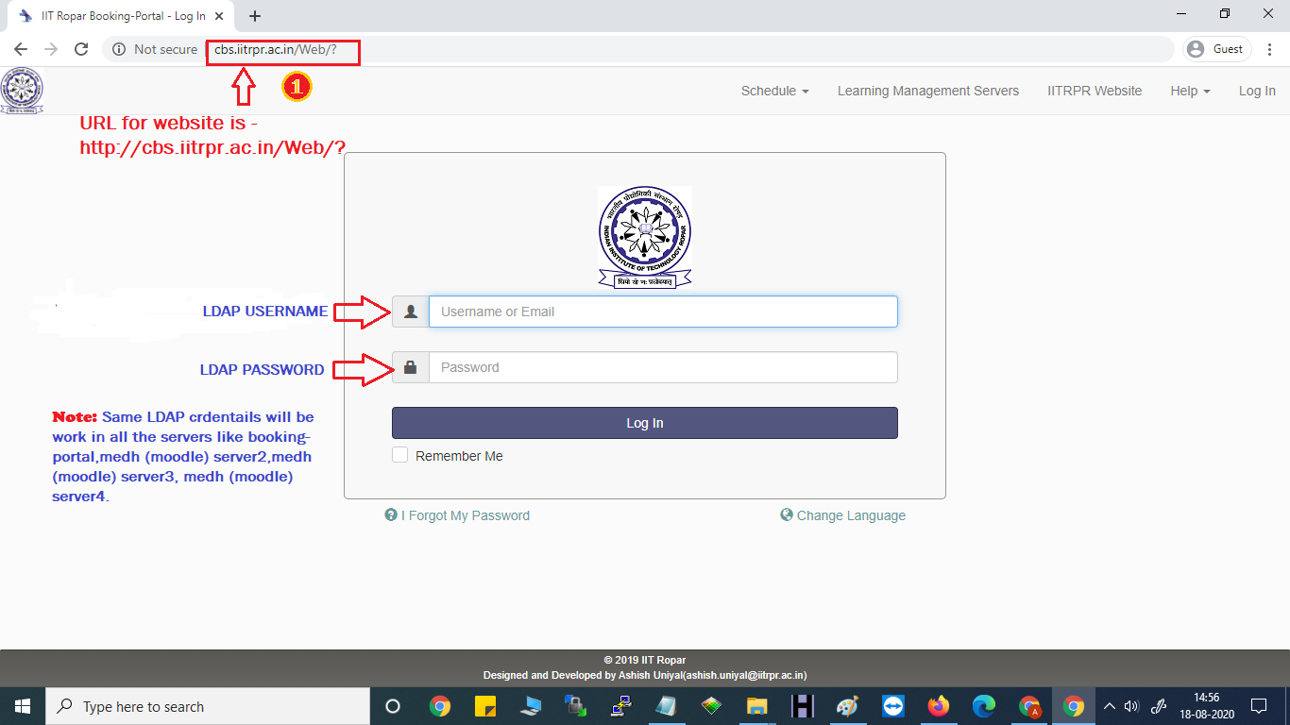
- Click on the menu link schedule and select the room as for which you want to create reservation.
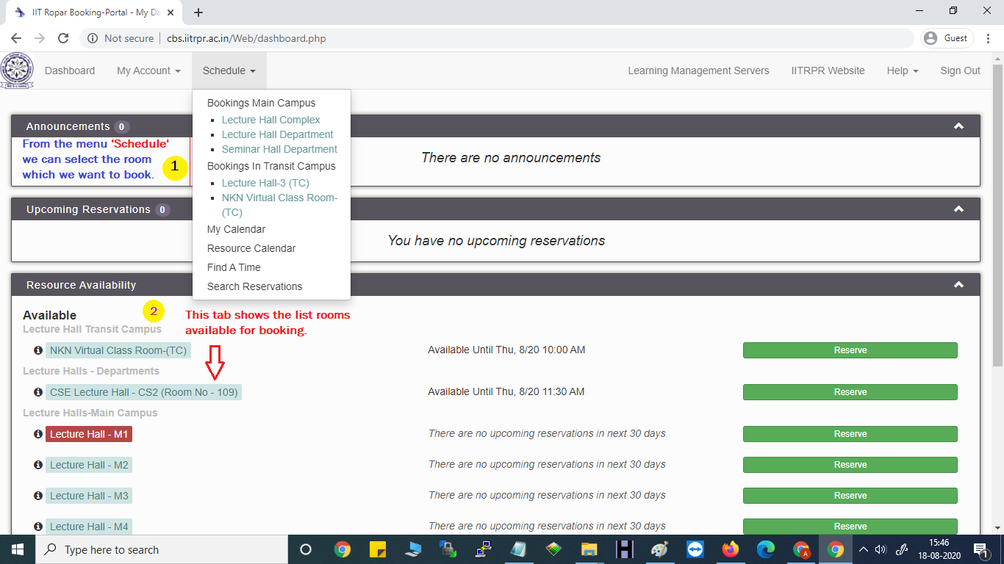
- Please select the time slot as shown in the below screenshot.
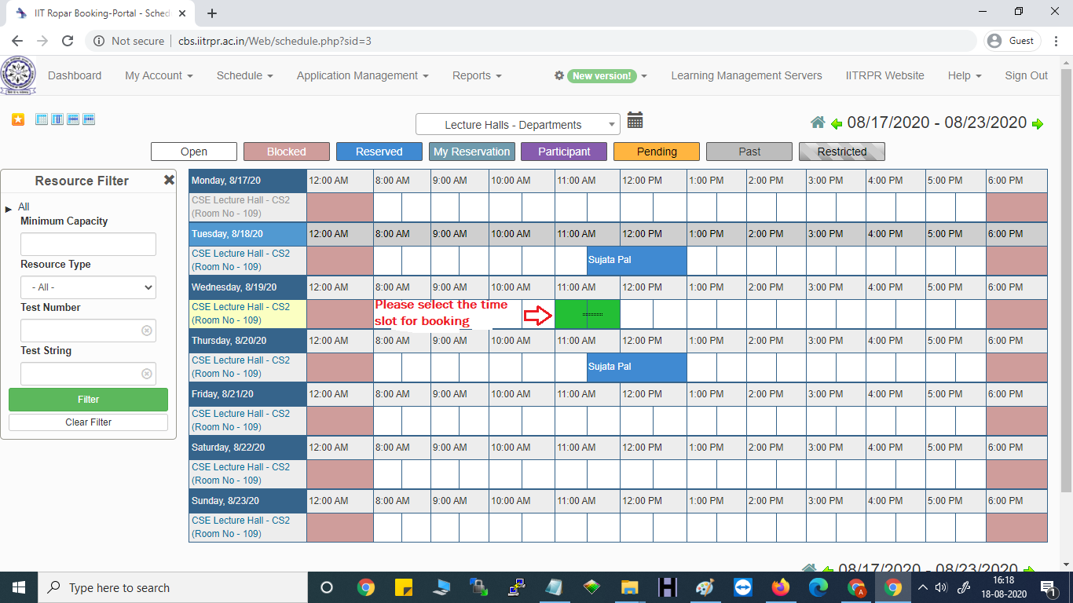
- Select the start and end time of your reservation and click on the create as shown in the screenshot below.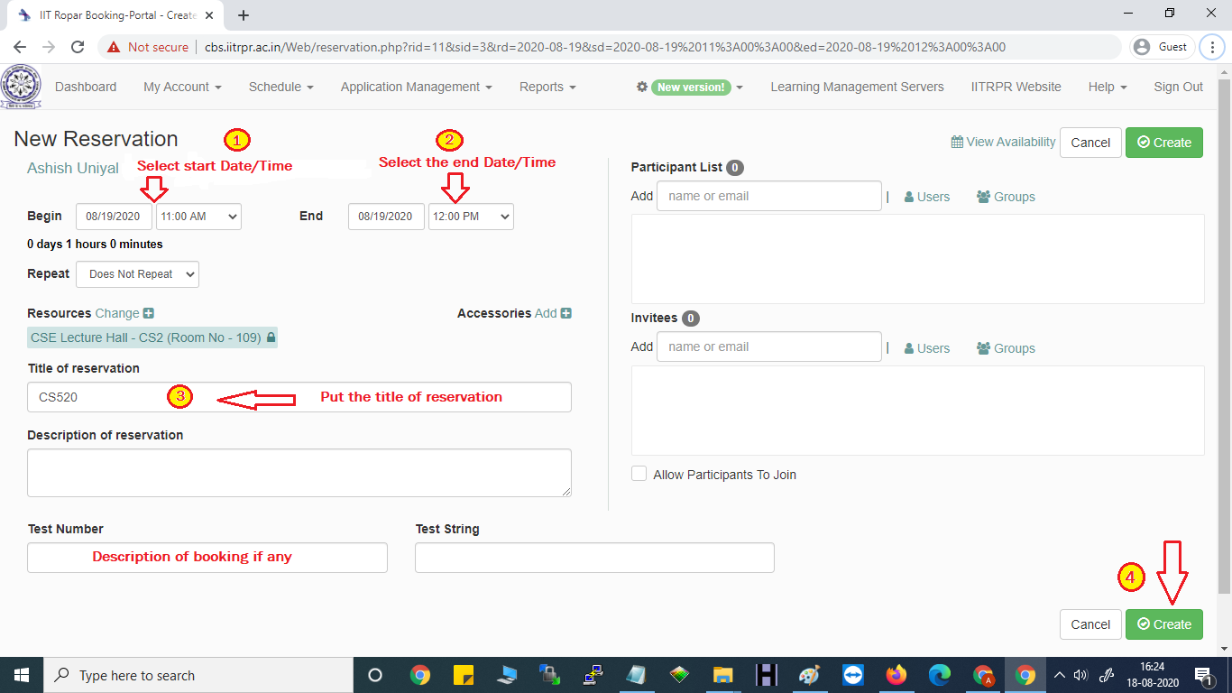
- Now Your reservation has been created and sent for approval to admin. An email for you booking will also sent to your registered email id. Your reservation will be in pending mode until administrator approves it. Yellow box shows your reservation is in pending. Please see the below screenshot.
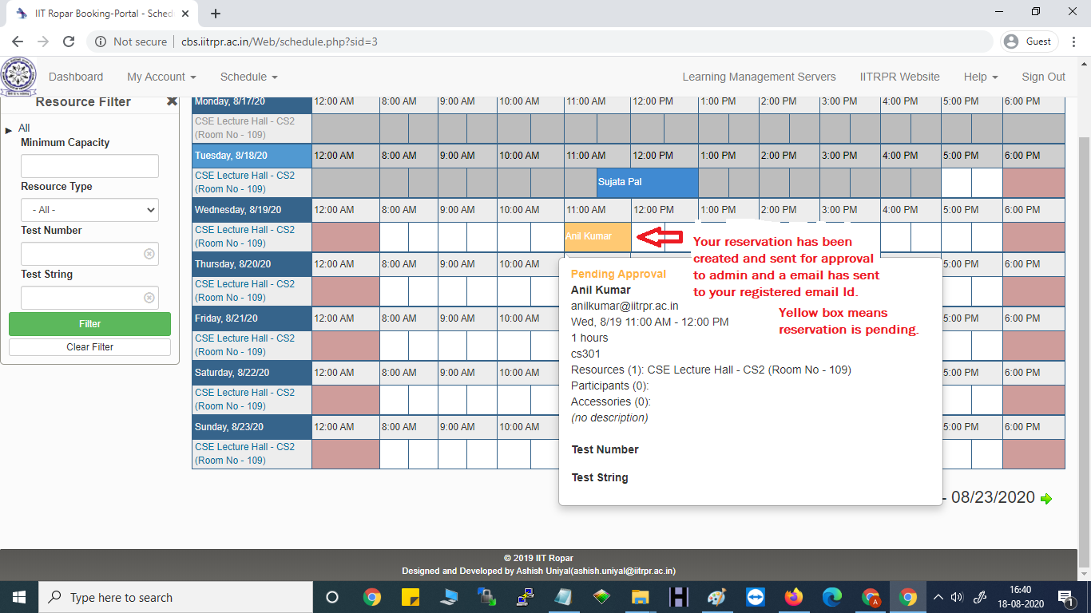
- After Your reservation has been approved by the admin you will get an email that your reservation has been approved by administrator. Please see the below screenshot.