Hands on Moodle Server (A Quick Tutorial)

Difference Between Moodle and CRP (course registration portal)

- The Moodle is a LMS (Learning management system) used for e-learning purposes and activities (ex-medh server2, medh server3, medh server4).

- On other hand CRP (Course Registration Portal) is a course registration portal where students can register for courses, add/drop courses and audit/withdrawal courses. Faculty members can accept the add/drop and audit/withdrawal requests, can see their course roll list and submit the online grades.

- The current servers (medh2, medh3, medh4) are Moodle servers and used for e-learning purposes such as uploading lectures, videos and other learning materials.

- Although there is a link given in the Moodle dashboard page which will redirect you to the CRP portal. (In which you can do the activities of the crp) as shown below, but both are different.
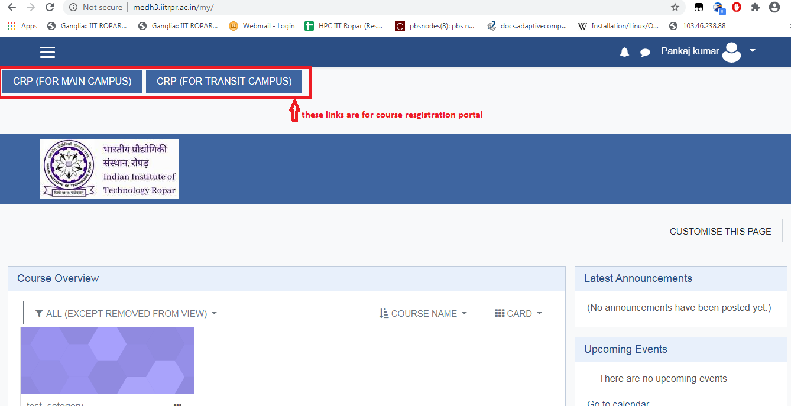

How to enroll users as a student/teaching assistant in the course:
Although users can enroll in a particular course by using the enrollment key, a teacher can also enroll students to their own course.
A teacher can also enroll students as teaching assistants (editing teacher) in their course.

The steps for adding students/TA in a course is as follows:
- First enter the course in which you are assigned as a teacher.
- Click on the three lines present in the top right corner of the page to open the sub-menu as shown in the image below:
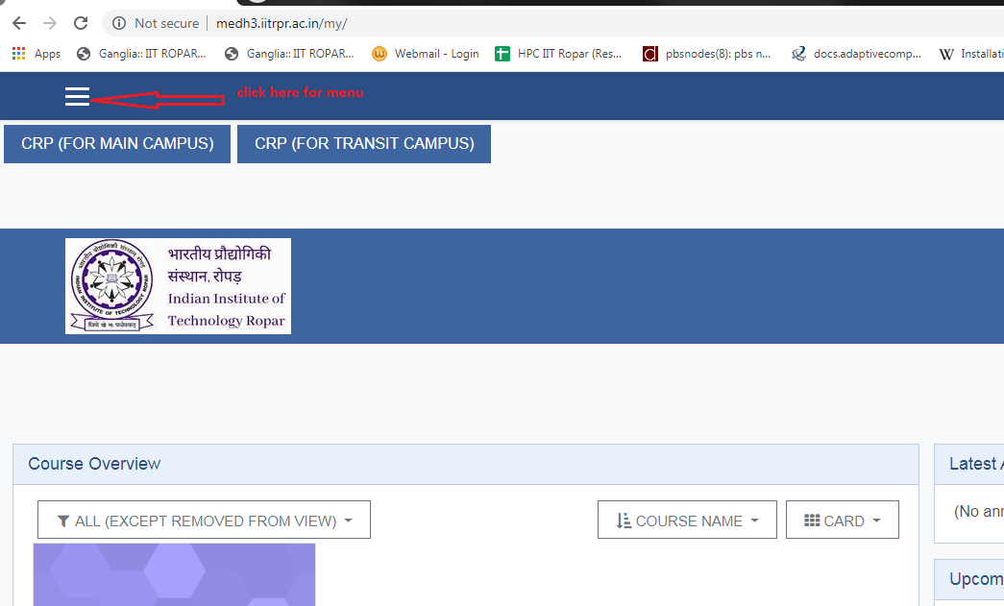

- After the menu is opened click on the participants option.
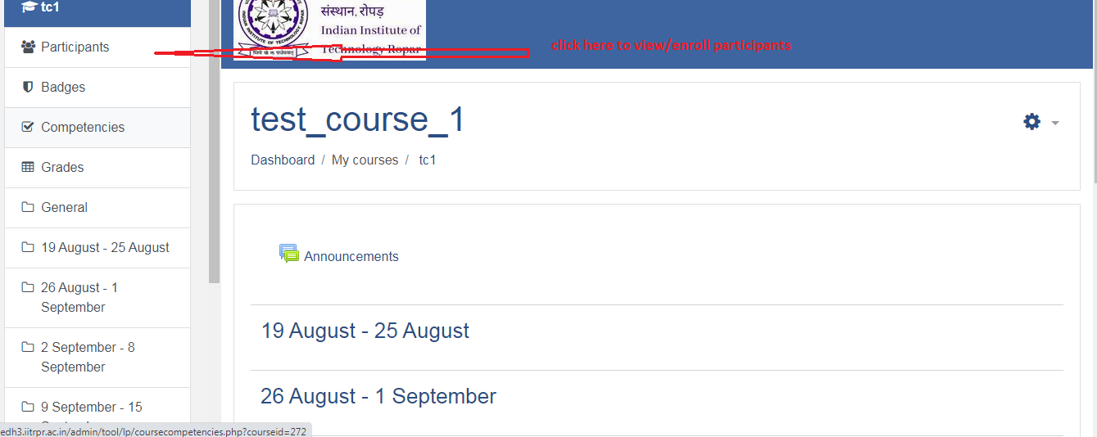

- On clicking on participants option, a new page will open which shows the list of currently enrolled users.

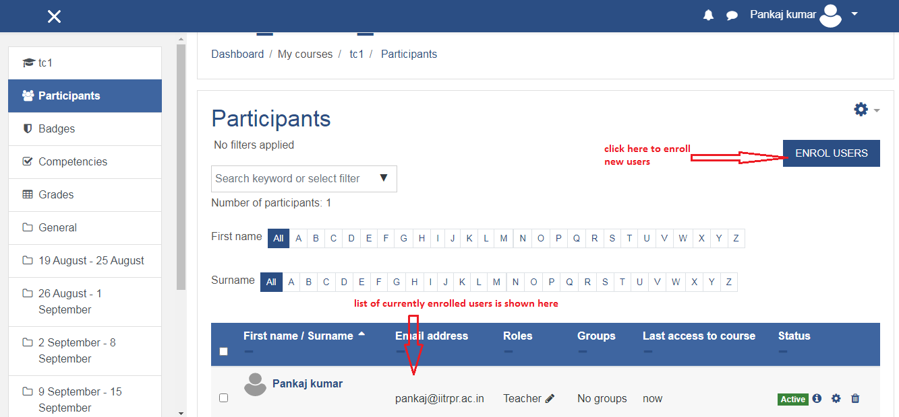

- In this page you can click on the option ENROLL USERS to enroll new users in your course.
- After you click on the Enroll users option a new dialog box will appear. In that you can select the users and their role.
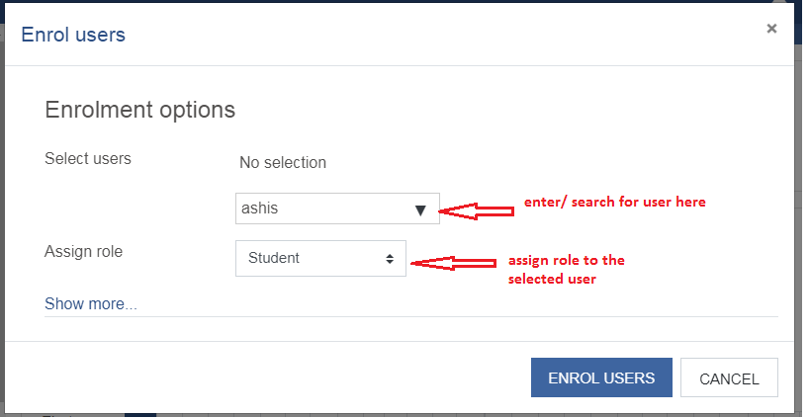
- After selecting the required user and their role click on the ENROLL USERS button.
- The new user will be now shown in the list.

In case if user is already enrolled in the course and you want to only change its role, you can change it from the list also
- For that first go to the list of participants.
- Find the particular user for which you want to change the role.
- Click on the pencil icon shown after the role field of the user.
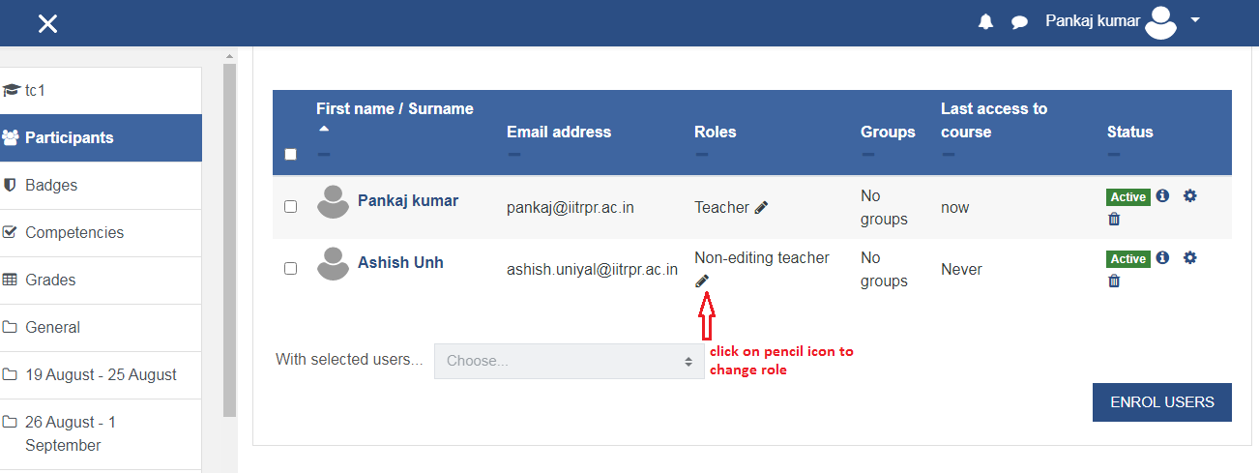
- Now delete the previously assigned role (by clicking on the “X” icon shown before the role), and select the new role from the list (by clicking on the drop down box).
- After you select the required role, click on the save icon to save the role as shown in the below image.
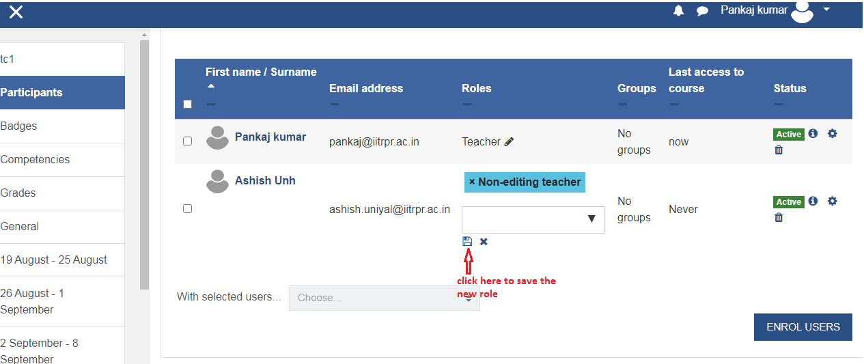
- After that the role column will show the newly assigned role of the user.

