Frequently Asked Questions – Moodle and CRP

The flow chart below shows the relationship between Moodle and CRP.

Please note CRP stands for Course Registration Portal which is used for Pre-registration for a semester as well as for Add / Drop activities.

Moodle is a Learning Management System platform for hosting course contents and any other activity in a course during the semester. However, students need to enrol in a course on Moodle using an enrolment key provided by IT section for each semester.

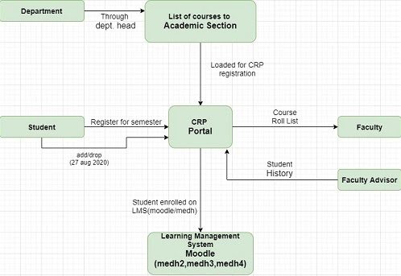

Is there a difference in list of participants (students+teacher+TA+...) and list of students registered in a course on CRP (Course Registration Portal)

Yes, As shown in the figure above, CRP has list of all students who meet all conditions to register for a course and have done the registration as per the Institute academic guidelines. The List of students enrolled on Moodle are the students who have enrolled themselves on Moodle after registering on CRP + who are yet to make up their mind about continuing with the course and might register on CRP during Add / Drop. For all practical purposes, CRP is the official record with academic section which will be considered for awarding credits to a student in a course.

Does the registration list from CRP get imported to Moodle?
No, at the moment, it is not imported into Moodle. The students self-enrol in a course on Moodle based on a key pattern provided by IT section. They may enrol in more or less number of courses than they have registered for on CRP. At the end of Add / Drop, it is the responsibility of faculty to check that the registration list form CRP and enrolment on Moodle match. For semester-I, 2020-21, the last date for add/drop is 27th August 2020.

How do students enrol themselves to Moodle?
The students go for a self enrolment in a course on Moodle using the key pattern provided by IT section.

How do I connect to Learning Management System Moodle?
Three Moodle servers have been set for semester-1, 2020-21
medh2.iitrpr.ac.in: This hosts courses with codes for all the branches which have a pattern XX1XX, XX2XX, which means numeric 1 or 2 are preceded by two alphabets.

medh3.iitrpr.ac.in: This hosts courses with codes for all the branches which have a pattern XX3XX, which means numeric 3 is preceded by two alphabets.

medh4.iitrpr.ac.in: This hosts courses with codes for all the branches which have a pattern XX4XX or XX5XX or XX6XX or XX7XX which means numeric 4 or 5 or 6 or 7 is preceded by two alphabets.

Exceptions:
In the above situation medh4 had about 86 courses hosted on it, so we were forced to go for these exceptions for load balancing.

All Civil Engineering Courses with codes XX3XX, XX4XX, XX5XX, XX6XX, XX7XX are located on medh3.

All Chemical Engineering courses with codes XX3XX, XX4XX, XX5XX, XX6XX, XX7XX are located on medh3

All Physics Courses with codes XX3XX, XX4XX, XX5XX, XX6XX, XX7XX are located on medh3

All Chemistry Courses with codes XX3XX, XX4XX, XX5XX, XX6XX, XX7XX are located on medh3

So Civil, Chemical, Physics and Chemistry have NO courses hosted on medh4.

How do I login to medh servers? I have forgotten my Moodle password.
If you do not remember the password: you can set the password by selecting the Forgot password option just below the login prompt. The login id will be provided by the IT section. If problem persists, please send an e-mail to itteam@iitrpr.ac.in

Is the login/password same for all Moodle servers (medh2, medh3, medh4)
Yes

Is the login / password different for Moodle and CRP.
For Faculty: Yes.
For students: No

How do I connect to CRP Portal
Login to Moodle and press the button located at the top to connect to CRP. Please see the first part of this Howto.

I have added one course on CRP and I don't see the new course.
Please note when you add a course on CRP, it needs to be approved by the course instructor and then by batch advisor. The change will get reflected in CRP after the process for both the approvals is over. However, you will need to enrol yourself on Moodle in the course using the enrolment key.

I am a faculty and I need to use the lecture recording facility. How do I book the facility?
Please log into cbs.iitrpr.ac.in to book for lecture recording facility. Please go through this Howto.

What is login /password for cbs.iitrpr.ac.in?
It is the same as for any of the Learning Management systems (medh2 / medh3 / medh4) i.e. Moodle

Where do I archive my lectures?
All faculty have been shared a folder by itfac@iitrpr.ac.in in their google drive. A folder has been created by the name semester-I-2020-21. Please archive your lectures / material in this folder. PLEASE BE ADVISED THAT THE PRESENT TRIAL VERSION OF WEBEX WILL EXPIRE ON OCTOBER 26 SO PLEASE TAKE BACKUP OF YOUR RECORDINGS AND OTHER FILES WHICH YOU MIGHT BE SAVING ON WEBEX CLOUD, AS THESE WILL NOT BE ACCESSIBLE AFTER THE EXPIRY OF THE TRIAL VERSION OF WEBEX.

Moodle App – you can install Moodle App to connect to medh2 / medh3 / medh4.

HowTo
How to upload videos to youtube channel?

How to make moodle course look like a website? (see Course format)

How to add TAs to your course? Please see part two of this Howto.

