**Dated:09.07.2025**

**WALK-IN-INTERVIEW FOR ADMISSIONS TO FULL-TIME PhD PROGRAMME AT IIT ROPAR**

A walk-in Interview for admission to the full-time PhD program in the first semester of the academic year 2025-26 in the **Department of Humanities and Social Sciences** is scheduled as follows. Interested candidates can attend in person/ offline. For more details, candidates are advised to visit the **PhD Admission Brochure 2025-26** on the Institute website.

|  |  |  |  |
| --- | --- | --- | --- |
| Department | Date of interview | Time | Venue |
| Department of Humanities and Social Sciences | 15th July 2025 | 10:00 am | HoD Office, Super Academic Block |

**Research Areas**

* **Psychology:** Applied Experimental Psychology: Emotion Regulation & Behaviour Change; Positive Psychology; Counselling Psychology; Cognitive Psychology
* **Interdisciplinary:** Marketing & Consumer Behaviour in Indian Yogic Systems
* **Management:** Operations & Supply Chain Management; Decision Sciences; Renewable Energy; Sustainability; Business Analytics
* **Economics**: Macroeconomics; Financial Economics; International Economics; Applied Econometrics; Economics of Climate Change; Microeconometrics; Spatial Econometrics; Economic Geography and Urban Economics
* **Philosophy:** Philosophy of Technology, Ethics
* **Linguistics:** Experimental Linguistics; Language Comprehension; Phonology; Evolutionary Linguistics

**Minimum Eligibility Qualification (MEQs) for admission to Regular Full-time Ph.D programmes**

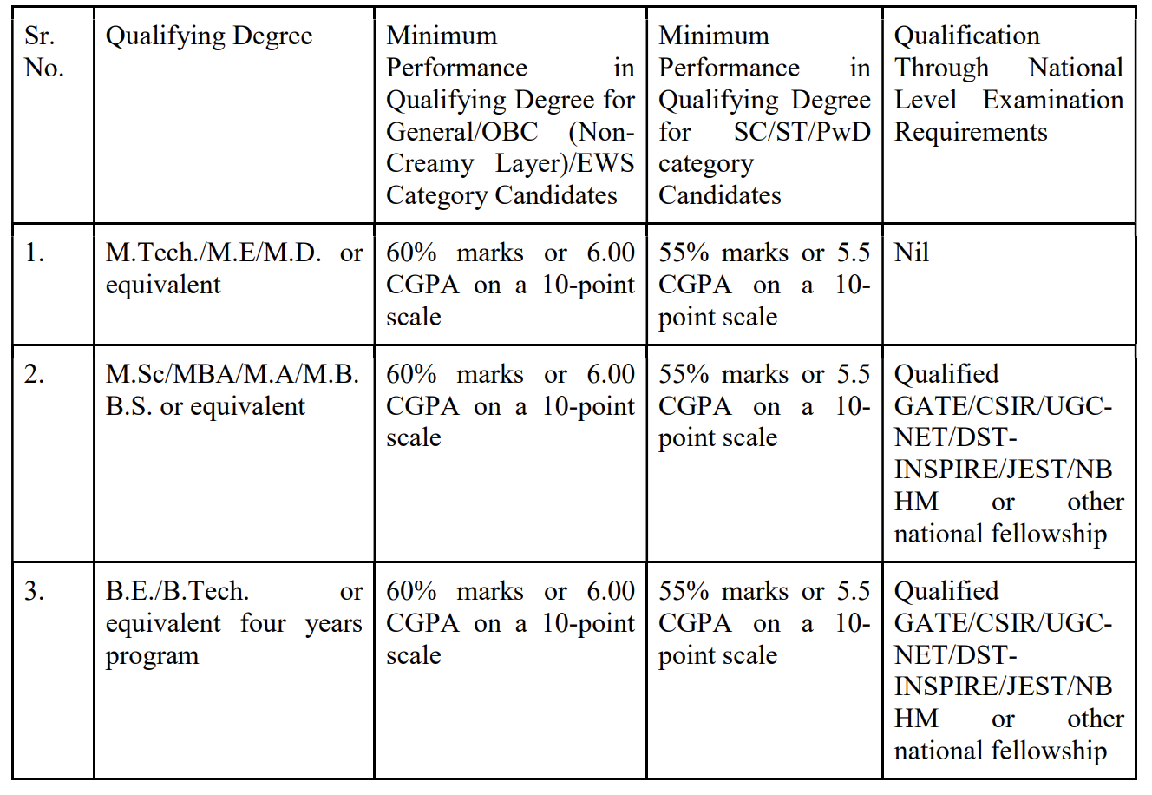

The department may fix higher cut-off/selection criteria than the MEQs

**Important Note:**

* The walk-in interview will be in physical mode only.
* IIT Ropar reserves the right to admit/ not admit for any of the advertised areas and apply appropriate criteria for shortlisting/selection of the candidates.
* The decision of the competent authority in all matters relating to the eligibility of the candidate, written test/interview and admission would be final and binding on all the candidates. In case of any dispute/ambiguity that may occur in the process of admission the decision of the Institute shall be final.
* All the details furnished in the application will be treated as final and no changes shall be entertained. Non submission of valid/required documents and/or incomplete application will lead to summarily rejection.
* Please bring the following documents at the time of the interview:
  + Duly filled application form in the prescribed format appended below.
  + All your original certificates and also self-attested photocopies of the certificates (from Class X onwards).
  + Qualifying certificate of the **GATE/UGC NET/CSIR/UGC-JRF/BET JRF/INSPIRE/NBHM or any other national fellowship**)
  + Those who belong to SC/ST/OBC/OBC-NCL/General-EWS category must produce a certificate of the same. Certificates related to OBC-NCL/EWS should be issued in the current financial year as per DOPT format.
  + Any other relevant documents (e.g., experience certificate, etc.).
  + One updated resume & passport size photograph.
* Application Fee: Women candidates & SC/ST/PwD category candidates: Rs. 100/- All other candidates : Rs. 200/- . The fee is to be paid by SB Collect (Online Payment System). Applications without online payment details will not be considered. Fees payment method is as follows:
* Procedure for payment of application fee through SB collect:

1. Go to [https:**//www.onlinesbi.com/**](https://www.onlinesbi.com/)

2. Select SB collect.

3. Tick the terms and conditions and continue.

4. Select state - Punjab.

5. Select educational institute – I I T Ropar (Type I I T Ropar after giving space in each letter of IIT).

6. Select the option for the payment category.

7. Pay the requisite fee.

One application fee is valid for a single application. The application fee is non-refundable.

The interested candidates are requested to visit IIT Ropar, Main campus, Rupnagar, Punjab 140001 for a walk-in Interview as per the given schedule.

Note: The candidates need to make their arrangements for travel. No TA will be provided. The candidates need to make their arrangements for accommodation in Ropar/Rupnagar city; however, office-hss-1@iitrpr.ac.in may be approached 2 days before attending the interview if accommodation is needed inside the campus.

Note: Accommodation inside the campus is subject to availability and may be chargeable.

For any queries related to this offline interview process, send an email to office-hss-1@iitrpr.ac.in

**INDIAN INSTITUTE OF TECHNOLOGY ROPAR**

**APPLICATION FORM**

1. **Personal Details**

| Full Name (In capital) | |  | | |
| --- | --- | --- | --- | --- |
| Name of Department applying | |  | | |
| Research Area(s) | |  | | |
| Date of Birth (DD/MM/YY): | | | Category GEN  (SC/ST/OBC/EWS): | Affix a recent passport size photo |
| Marital Status (Single/Married): | | | Gender (Male/Female) |
| Nationality | |  | | |
| Present Address for Communication | | | Permanent Address | |
|  | | |  | |
| Mobile/Phone No. |  | | Email: | |

**2. Details of School/University/Institute Studied (From Matriculation Onward)**

| **S.**  **No.** | **Degree** | **Discipline** | **University/Institute** | **Regular/**  **Part-time** | **Year** | **%Marks**  **/CGPA** | **Division** |
| --- | --- | --- | --- | --- | --- | --- | --- |
|  |  |  |  |  |  |  |  |
|  |  |  |  |  |  |  |  |
|  |  |  |  |  |  |  |  |
|  |  |  |  |  |  |  |  |
|  |  |  |  |  |  |  |  |

1. **Details of External Fellowship (CSIR/UGC-JRF/BET-JRF/INSPIRE/NBHM or any other national fellowship etc.)**

| **Qualifying**  **Examination** | **Branch** | **Year** | **Valid Up**  **to** | **Percentile** | **Score** | **All India**  **Rank** | **duration of fellowship** |
| --- | --- | --- | --- | --- | --- | --- | --- |
|  |  |  |  |  |  |  |  |

1. **Details of Qualifying Examination (NET/GATE or any other equivalent examination)**

| **Qualifying**  **Examination** | **Branch** | **Year** | **Valid Up**  **to** | **Percentile** | **Score** | **All India**  **Rank** |
| --- | --- | --- | --- | --- | --- | --- |
|  |  |  |  |  |  |  |

1. **Professional Experiences (Teaching/Research/Industrial)**

| **Name of Organization** | **Designation** | **Nature of Work** | **From** | **To** |
| --- | --- | --- | --- | --- |
|  |  |  |  |  |
|  |  |  |  |  |
|  |  |  |  |  |

1. **Research Publication/Patents/Awards/Accomplishments (if any):**

1. **Any other Information (use a separate sheet if required):**

**DECLARATION**

I hereby declare that I have carefully read the instructions and particulars supplied to me and that the entries made in this application form are correct to the best of my knowledge and belief. If selected for admission, I promise to abide by the rules and discipline of the Institute. I note that the decision of the Institute is final in regards to the selection. The Institute shall have the right to expel me from the Institute at any time after my admission, provided it is satisfied that I was admitted on false particulars furnished by me or my antecedents prove that my continuance in the Institute is not desirable. I agree that I shall abide by the decision of the Institute, which shall be final.

Place:

Date: Signature of the Applicant