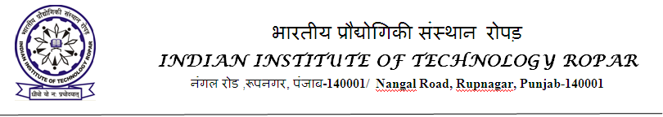
Advertisement
Applications are invited for the position of Junior Research Fellow (JRF) to work in the BRNS sponsored project title " Development of peptide-based infection imaging agents and deciphering interaction mechanisms of novel peptides with model cell membranes " under the supervision of undersigned, [Project No. 58/14/12/2022-BRNS/37058 ]. The Position is available immediately.
Positions: One (to join immediately)
Duration: 1 year (extendible on annual basis up to 2 years or till the completion of the project, whichever is earlier)
Essential Qualifications: M. Sc., M. Pharm. or equivalent degree in Chemistry with 60% marks (or CGPA 6.5/10) and valid GATE/CSIR/LS-NET/GPAT/INSPIRE qualified.
Desirable Qualification: The research experience in synthetic organic chemistry and medicinal chemistry.
Emoluments: Commensurate to the experience (as per BRNS rules)
WALK IN INTERVIEW
Candidates having the above qualification are invited to appear (along with a brief Bio-data and all original Certificates) for a walk-in- interview (in offline mode) before the selection committee on 22nd March, 2023 at 11 AM in the Dept. of Chemistry, IIT Ropar. No TA/DA will be paid for attending the interview. Please note that the post is purely temporary and is co-terminus with the project.
Candidate, who wants to appear online, should email to anupamba@iitrpr.ac.in and fill google form (https://forms.gle/cJG3fYZLEcKbqExC9 ) latest by 19th March 2023, 19:00 hrs. The applicants should clearly mention their interview mode of choice (online). All the shortlisted candidates for online interview will be informed through email by 19th March 2023. The candidate, who wants to appear in person, can directly appear for the interview on 22nd March.

Important Dates:
Time and Date of interview: 11 AM, 22nd March, 2023.
Dr. Anupam Bandyopadhyay (Principal Investigator)
Department of Chemistry
Indian Institute of Technology Ropar,
Rupnagar-140001 Punjab
E-mail: anupamba@iitrpr.ac.in Group Webpage: https://anupamba.wixsite.com/ab-lab

APPLICATION FORM

For the position of JRF to work in the DST-SERB sponsored project [Project No. CRG/2022/007757]

Post Applied for:
Personal Details
Full Name  (In Capital) |  |  |  |  | Affix Recent Passport Size Photo
Date of Birth  (DD/MM/YY) |  | Gender (Male/Female)
Marital Status  (Married/Unmarried) |  | Nationality
Address for Communication |  | Permanent Address
Mobile/Phone no. |  | E-mail

Education Background (From Undergraduate Onward)
S. No. | Degree | Board / University | Regular/ Part time | Year | Division | % Marks /CGPA

Qualifying Examination (GATE/CSIR/UGC/NET/ Others)
S. No. | Qualifying Examination | Branch | Year | Valid up to | Percentile | All India Rank | Any other information
Professional Experience (if any)
S. No. | Designation | Name of Organization | Period |  | Nature of Work
 |  |  | From | To

Research Publication (if any)

Awards, patents, prizes etc (if any)

Any other Relevant Information

DECLARATION

I hereby declare that I have carefully read the instructions and particulars supplied to me and that the entries made in this application form are correct to the best of my knowledge and belief. If selected, I promise to abide by the rules and discipline of the Institute.
I note that the decision of the Institute is final in regard to selection. The Institute shall have the right to expel me from the Institute at any time after my selection, provided it is found that I was admitted on false particulars furnished by me or my antecedents prove that my continuance in the Institute is not desirable. I agree that I shall abide by the decision of the Institute, which shall be final.

Place :…………

Date : ………… Signature of Applicant

