**How to upload the lecture on YouTube?**

1. Login with your iitrpr or Gmail id

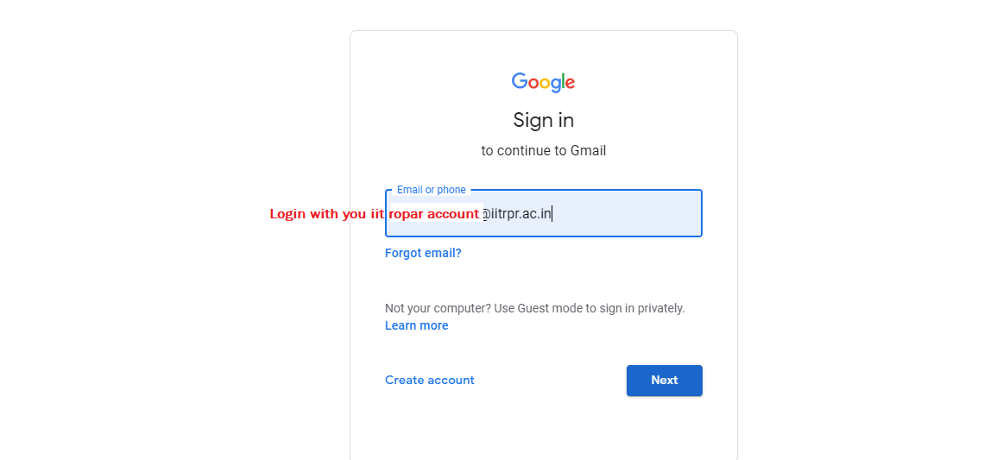

1. After login, select the YouTube option from the right side

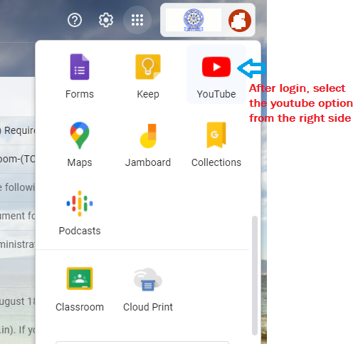

1. Select the YouTube studio as shown in image below.

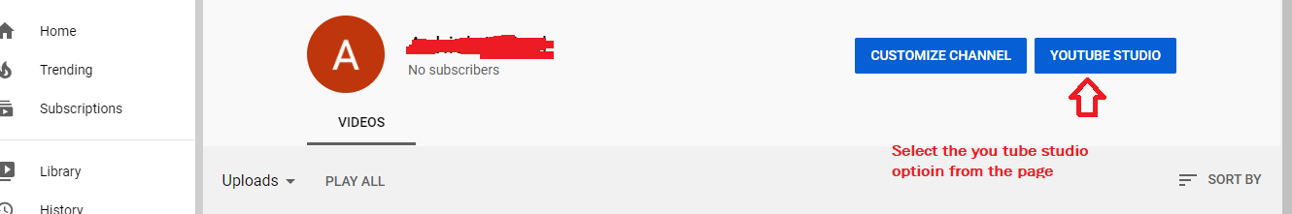

1. Select the upload videos option as shown below.

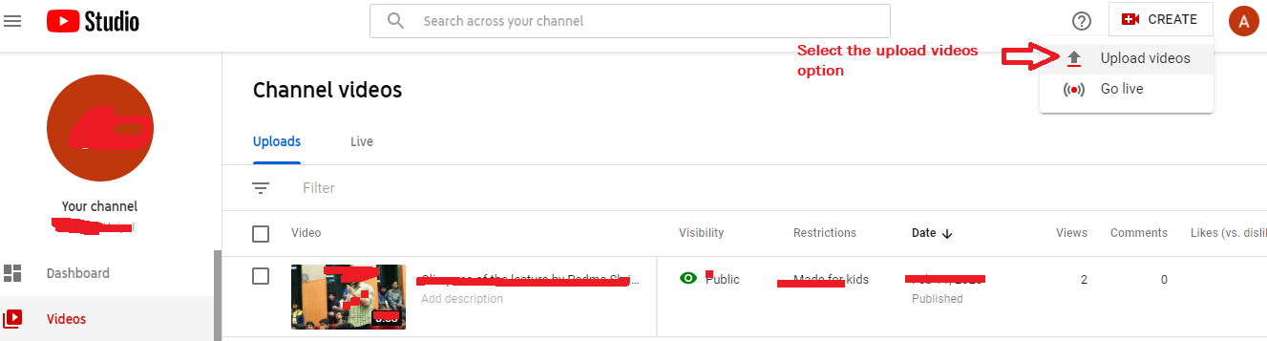

1. You will see an option for uploading a video file. You can also drag and drop your lecture video directly here. As shown below.

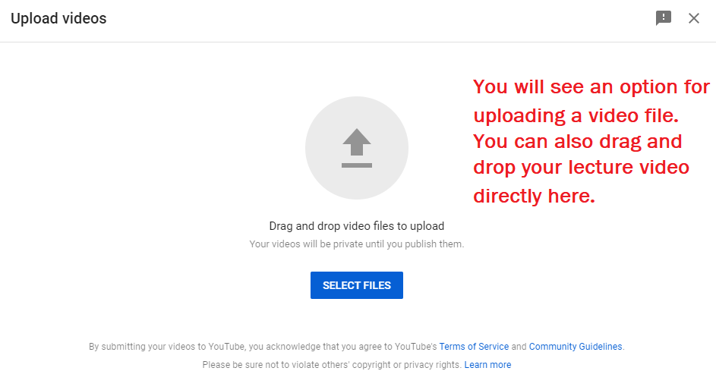

6.Give name to your uploaded video and click next as shown below.

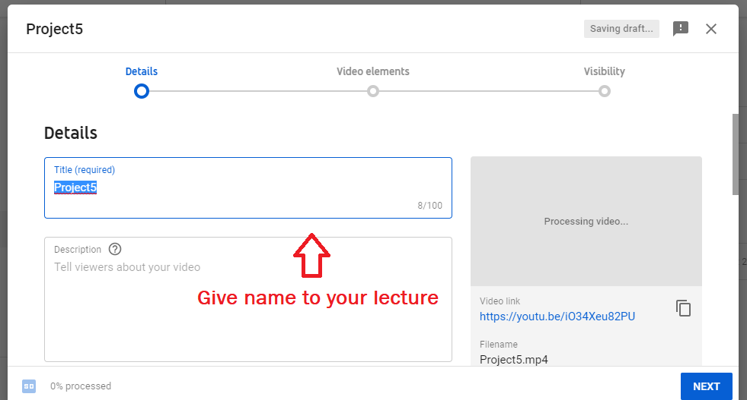

1. Now, select option weather it is for kids or not and it private, public etc. and click next

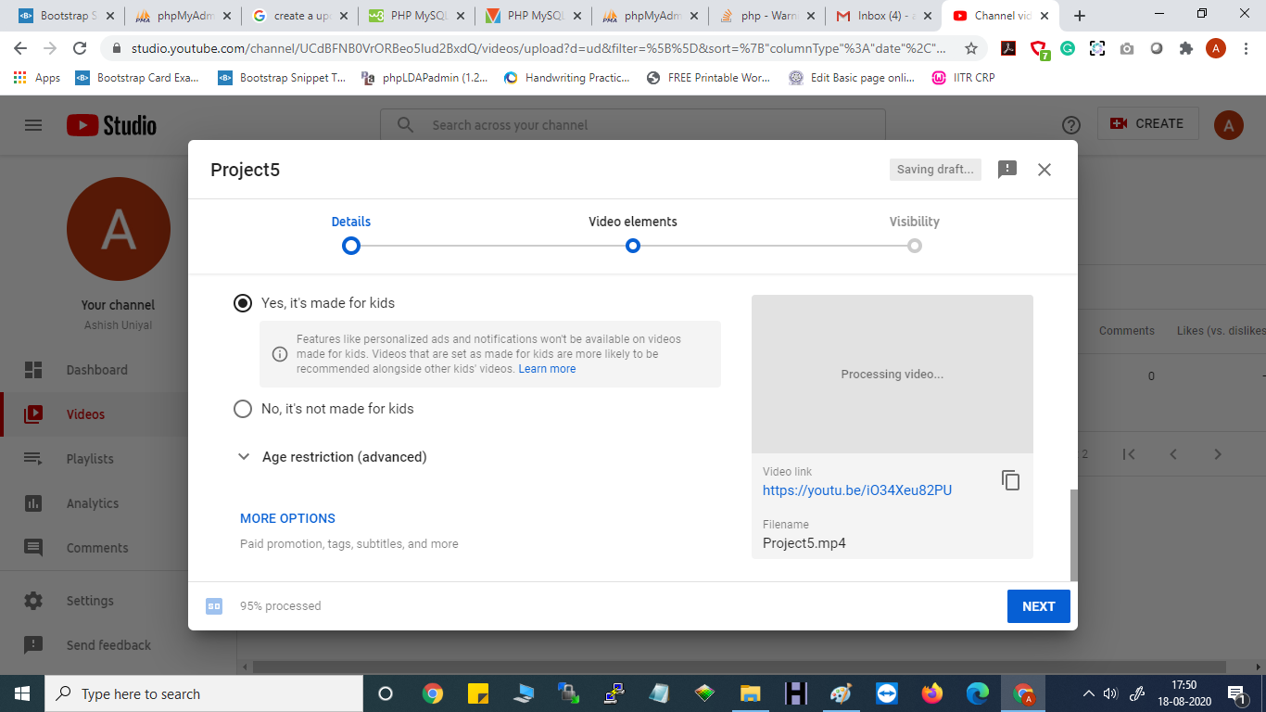

1. Now Your video has been uploaded and you will be redirected to following page. Copy the URL of video and share it with students on Moodle

