Instructions for filling up the application form for a faculty position at IIT Ropar
Access this spreadsheet (Application-form-for-IIT-Ropar or Basic-Application-Data)and fill it electronically (and not by hand), and follow the FOUR steps given below.
If you enter data using “copy” and “paste” from another document, then it is suggested that you paste data into the formula bar shown below.
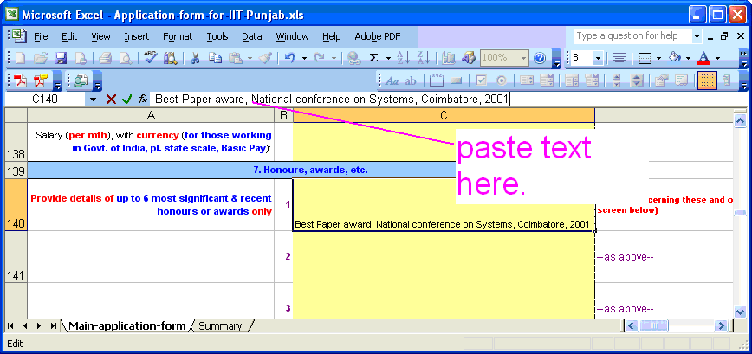
If for some reason you are able to see only the first line of the data in any cell (or field) and not the rest of it, then we suggest you select the relevant cell (or cells) and go to “Format”, then to “Cell” and select “Alignment” and finally select “Wrap Text”. XXX-YYY-nnnnn-Additional-Details.doc
- STEP 1: Save this spread-sheet as a Microsoft Excel file, with your full name and the last 4 digits of your phone number (such as “Ashok-Garg-4321-Basic-Application-Data”.
- STEP 2: Separately prepare a document in .doc or .pdf (use this sample file (or Additional-Details)) with information THAT IS NOT ALREADY COVERED IN THE “Basic-Application-Data. This could be on your educational background, employment details, honours and awards, PhD thesis guided, sponsored projects, publications, and patents ONLY, and save it with a file-name that identifies you uniquely using the 4 last digits of your phone number (such as "Ashok-Garg-4321-Additional-Details").
- STEP 3: Email the two documents "XXX-YYY-nnnnn-Basic-Application-Data" (the spreadsheet) and the "XXX-YYY-nnnn-Additional-Details" file (you have prepared under Note 2 above) to:
- STEP 4: If you currently work for Govt. of India, print this spreadsheet and the above .doc or .pdf file, and send them to Registrar, IIT Ropar through proper channel (or your HR or Establishment office).

