**X-Ray Photoelectron Spectrometer (XPS)**

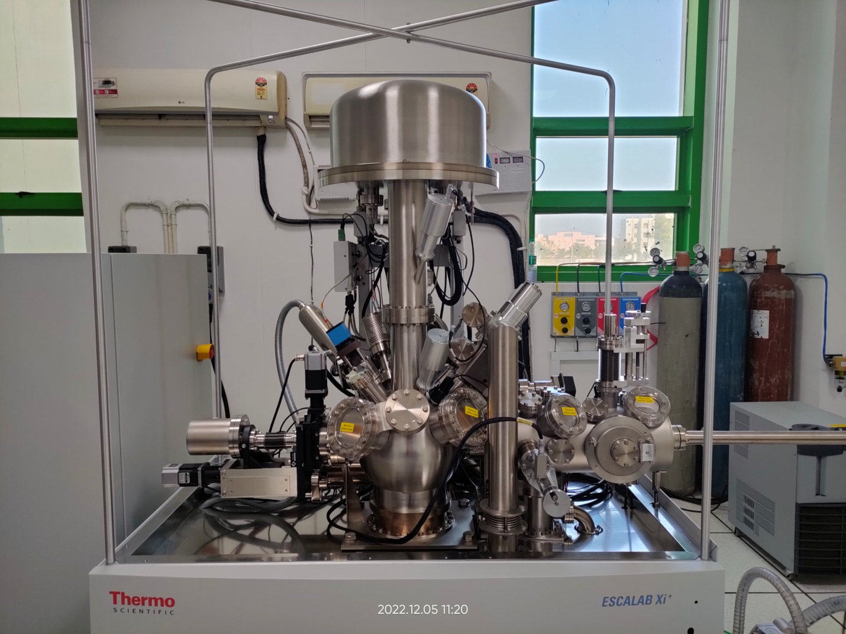

X-ray photoelectron spectrometer is a surface sensitive technique for characterizing a broad range of materials including conducting, semiconducting, insulating solid materials in the form of bulk or powder or thin film, and soft materials such as organics, rubber, polymers samples, nano materials, chemical compounds, alloys, metals, batteries, catalysts, semiconductors etc.

Thermo Fisher Scientific Escalab Xi+, recently installed in the Central Research Facility of IIT Ropar, provides all in one solutions to your surface analysis problems. The system provides point analysis, area scans, line scans, survey spectra, narrow region spectra, mapping/parallel imaging of surface and also allows depth profiling, angle-dependent XPS measurements, heating and cooling experiments, REELS, ISS and UV photoelectron spectroscopy. This XPS spectrometer is a complete ultrahigh vacuum (UHV) system which will provide researchers an edge to conduct world class research in all leading areas of multi-disciplinary.