SCHOOL OF MECHANICAL, MATERIALS AND ENERGY ENGINEERING

Product Design & Realization Computer Laboratory

Location: Room No. 126

Faculty-In- Charge | Laboratory Staff
Dr. Anupam Agrawal  Assistant Professor, Room no. 224, admin block  Tel: +91-1881-242165 (Office),  Email: anupam@iitrpr.ac.in | Mr. Rajiv Kumar  Room no. 126  Tel: 9417214971  Email: rajiv2320@sify.com

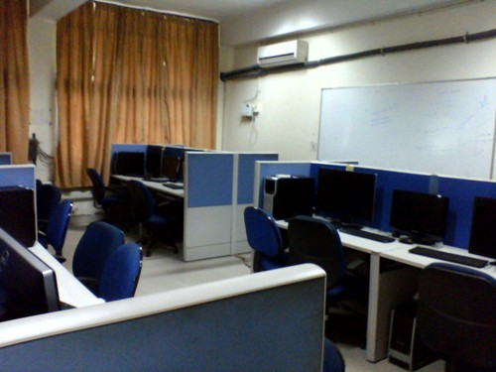 | 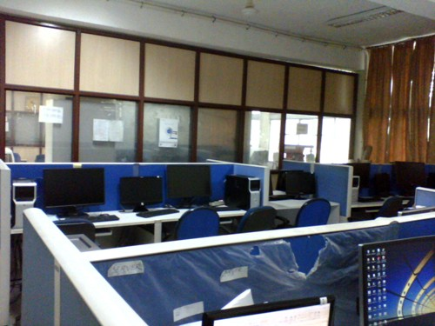
Systems equipped with Solidworks, Catia, Abaqus and Auto Cad | Arrangement in Laboratory

Facilities:
Approximately 30 workstations having configuration, as mentioned below:
Intel Xeon Quad core, RAM-8GB, Motherboard- Intel, Graphics-NVIDIA, Quadro 2000 1GB, Harddrive-320GB(mini), SATA Hard drive (7200rpm), Storage device-DVDRW, Network Controller- 100/1000 GB Ethernet, Operating system- Genuine Windows 7 Professional 64 bit, Keyboard: USB, Mouse Optical

All the workstations are equipped with a number of useful software; a few of them are listed below.

1. SolidWorks 2013
SolidWorks offers complete 3D software tools that let you create, simulate, publish, and manage your data. Our products are easy to learn and use, and work together to help you design products better, faster, and more cost-effectively.

2. Catia V5 R20
CATIA goes far beyond traditional 3D CAD software tools to offer a unique Digital Product Experience, based on the 3DEXPERIENCE platform. Sustainable development is driving companies around the globe to create a constant stream of innovative and inspiring smart products. Engineering, Design, Systems Architecture and Systems Engineering of these products becomes more demanding.

3. Abaqus/ CAE 6.11-1
It is a software suite for finite element analysis and computer-aided engineering, originally released in 1978. The name and logo of this software are based on the abacus calculation tool. The Abaqus product suite consists of four core software products.

4. AutoCAD 2013
AutoCAD is a software application for computer-aided design (CAD) and drafting. The software supports both 2D and 3D formats. The software is developed and sold by Autodesk, Inc., first released in December 1982 by Autodesk in the year following the purchase of the first form of the software by Autodesk founder.

Product Design & Realization Computer Laboratory
SCHOOL OF MECHANICAL, MATERIALS AND ENERGY ENGINEERING
RULES FOR USING PDRC LABORATORY
1. General Rules
- This laboratory is to be used ONLY for using the software related to the following fields (and NOT for any other purpose):
Product design, computer aided design/manufacturing, finite element analysis, any other mechanical engineering related software not listed above.
- Personal laptops are NOT allowed in the laboratory. If a student is found using a laptop, he/she will be debarred from using the laboratory for one month.
- In case of a system failure, for any reason, do NOT try to repair the workstation/unplug the mouse/LAN cable from the computers; ask the on duty staff for help.
- If you are using a USB memory stick, it must be scanned for viruses.
- When using the laboratory other than scheduled class timing, students must sign the logbook at the time of entry and exit.
- NO ETABLES/BEVERAGES are allowed inside the laboratory.
- Student must maintain discipline in the lab (proper seating).
- Shut down your workstation while leaving the laboratory.
2. Additional Rules (for using the laboratory after regular hours)
- If students need to use this laboratory after regular hours, they should form a group (of volunteers) to manage and take care of the laboratory, and seek written permission from the undersigned.
- Students of Mechanical Engineering Department (2nd year onward), ONLY, are allowed to use this laboratory after regular hours. The laboratory will open and close as per the details given in the other notice (volunteers’ duty chart).
- If students from other branches need to use this laboratory, they should take prior written permission from the undersigned.
- Shut down all the computers and arrange all the chairs while leaving the laboratory.
- Weekly report must be given by the volunteers to the undersigned
- If anything is found missing and/ or broken, fine will be imposed on the volunteers.

Non compliance with the above mentioned instructions will be taken very seriously and may lead to imposing a fine and/ or debarring the student from using the laboratory.
Contact detail:
Laboratory Assistant: Rajiv Kumar (Email: rajiv2320@sify.com, Cell No: 9417214971)
Faculty In Charge: Dr. Anupam Agrawal (Email: anupam@iitrpr.ac.in, Office no.: 2165)

Date: 11/07/2013 Dr. Anupam Agrawal
Faculty In Charge

