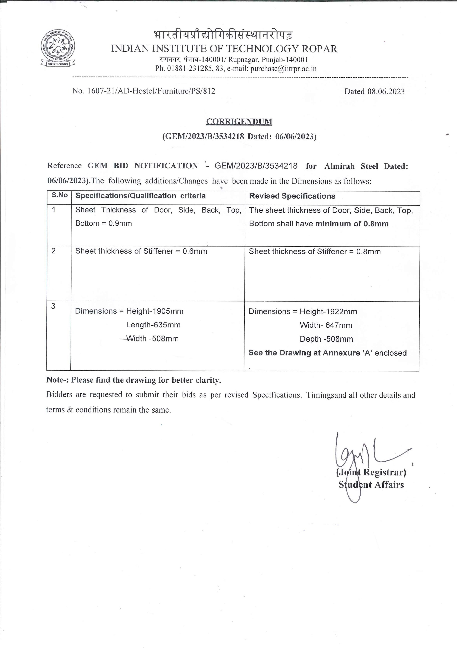

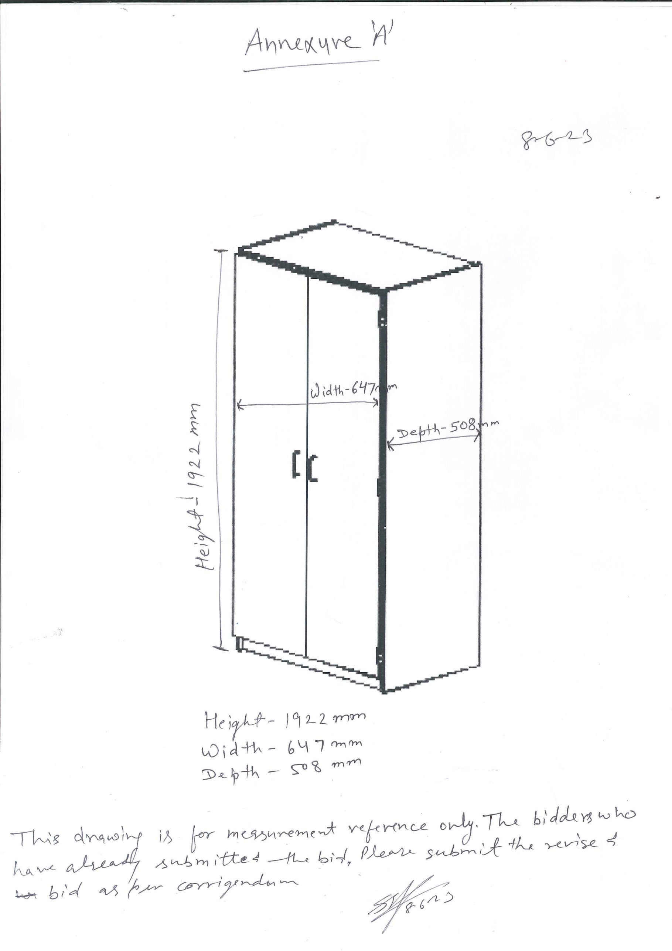

DECLARATION OF LOCAL CONTENT

(To be given on Company Letter Head – For value below Rs.10 Crores)

(To be given by Statutory Auditor/ Cost Auditor/ Cost Accountant/ CA for value above Rs.10 Crores)

Date:

To,

The Registrar,Indian Institute of Technology Ropar

Rupnagar, Punjab - 140001

Subject: - **Declaration of Local content**

Tender Reference No / GeM Bid No:

Name of Tender / GeM Bid: _______________________________________________________________

1. Country of Origin of Goods being offered:
2. We hereby declare that an item offered has % local content.

“Local Content” means the amount of value added in India which shall, be the total value of the item being offered minus the value of the imported content in the item (including all customs duties) as a proportion of the total value, in percent.

The bidders cannot claim services such as transportation, insurance, installation, commissioning, training and after sales service support like AMC/CMC etc as local value addition.

*“*False declaration will be in breach of Code of Integrity under Rule 175(1)(i)(h) of the General Financial Rules for which a bidder or its successors can be debarred for up to two years as per Rule 151 (iii) of the General Financial Rules along with such other actions as may be permissible under law.”*

Yours faithfully,

(Signature of the Bidder, with Official Seal)