**To add course description and change the format of the course**

**How to add course description**.

You can add a brief description to your course in moodle. It will be shown to the students/users in the course. To add the course description following steps are there:

1. Go to your course. There, on the top right corner click on the **“gear”** icon, a menu will appear. From that menu select the ***Edit Settings*** option.

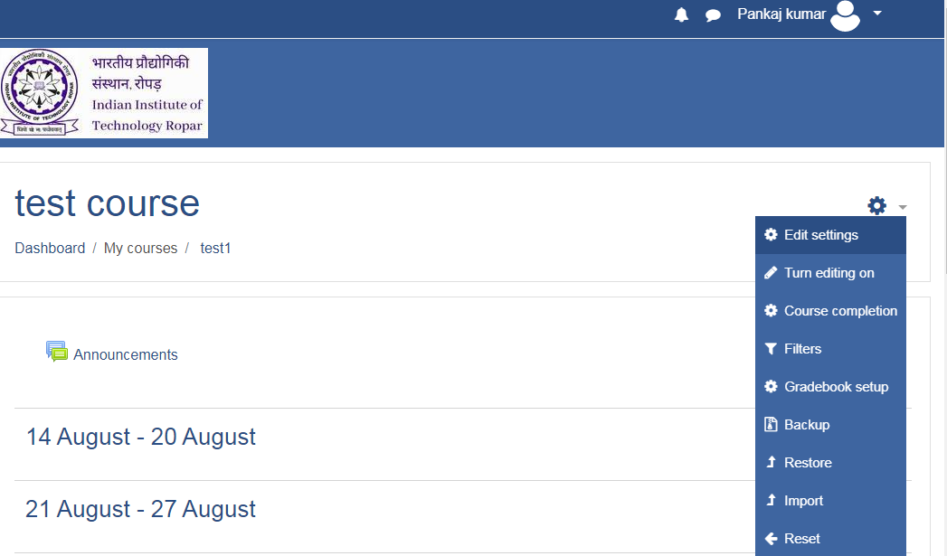

1. A page will open, in that page go to ***Description*** option by scrolling down, and in that ***course summary*** you can write a brief description about your course as shown below.

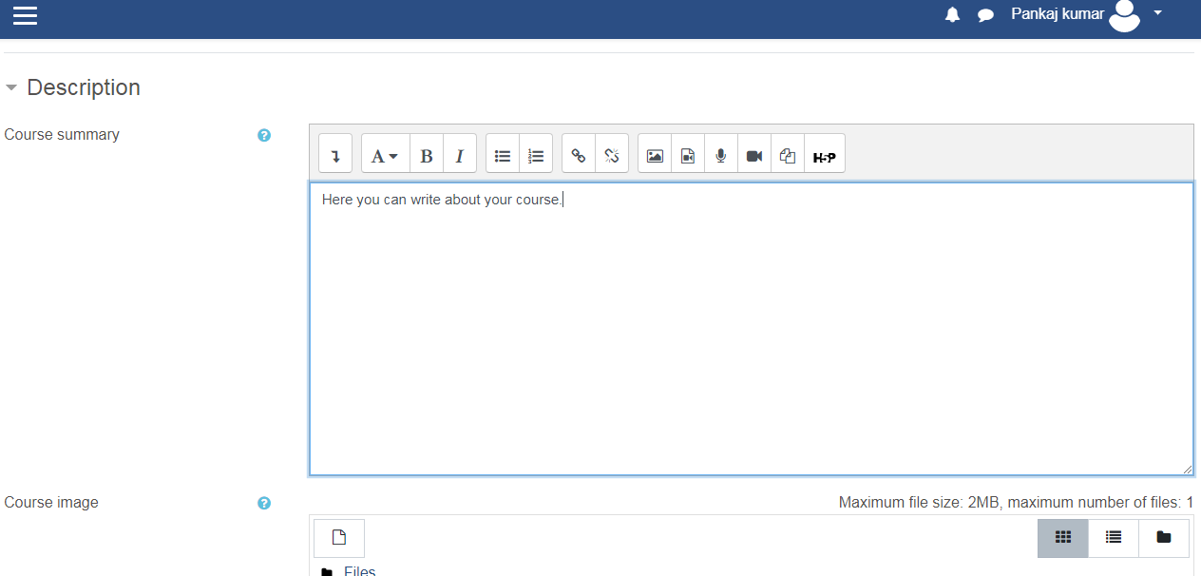

1. After writing the description scroll down and click on the ***save and display*** button.
2. Your added description will be then shown to students as below:

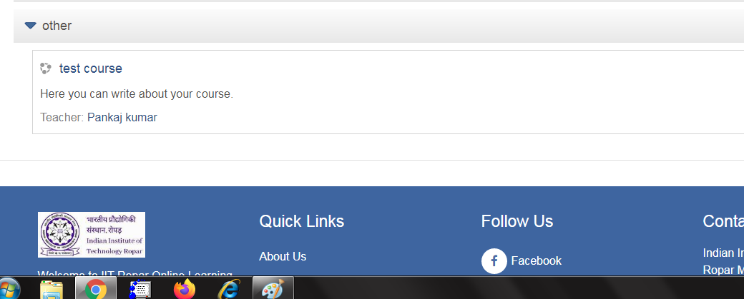

**How to change course format**

You can change the course format according to your requirements/choice.

To do so you can follow the below steps:

1. Go to your course. There on the top right corner click on the “**gear**” icon, a menu will appear. From that menu select the ***Edit Settings*** option.



1. A page will open, in that page go to ***course format*** option by scrolling down, and in that you can select the format of the course as shown below:

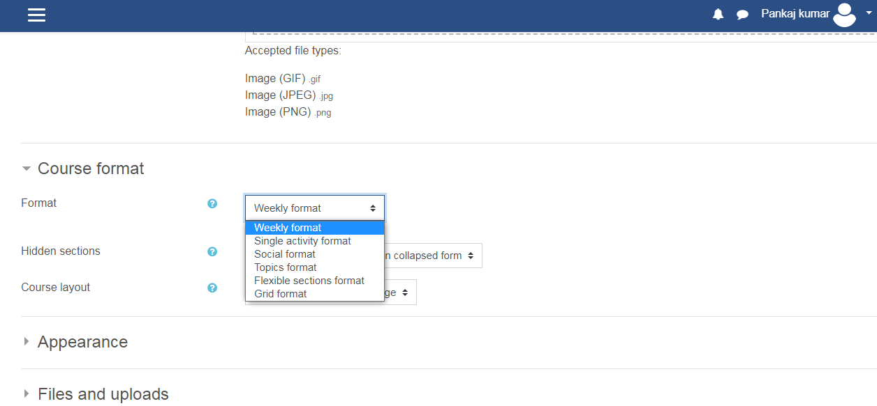

1. After selecting the particular format go to the bottom of the page and click on ***save and display***.
2. After that you are able to see the course in your selected format
3. Some of the examples of course format are shown below:

Weekly format

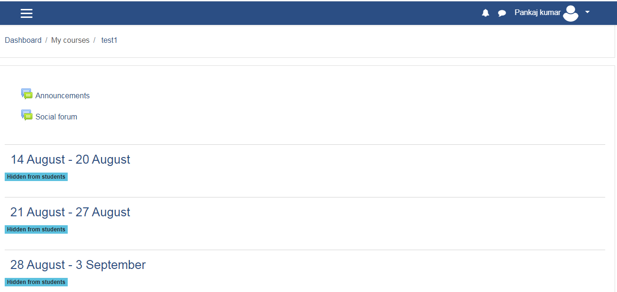

Topics format:

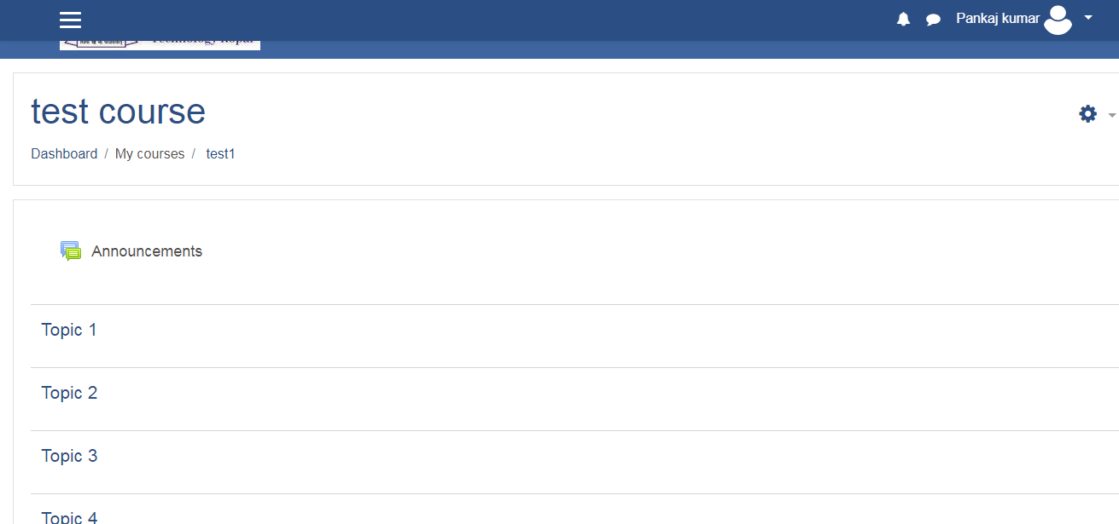

Sections format:

